**Progress Report: The Assigner Internship Test Assignment**

**Day 1: 11-11-2024**

**Task: Nav Bar and Hero Page**

**Status: Completed**

**Output:** 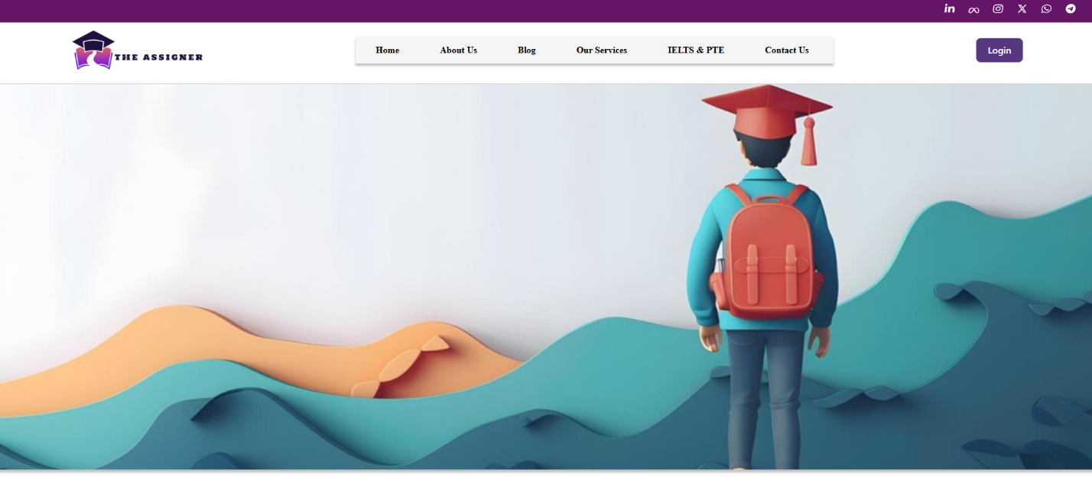

**Day 2: 12-11-2024**

**Task: Complete Page and Mobile version**

**Status:**

* **Stats Page: Completed**
* **IELTS Preparation Page: Completed**
* **Awesome Features: Completed**
* **Our services: Completed**
* **Our Assistance’s advantages: Completed**
* **FAQ Icon designs: Pending**
* **Services Star Icon: Pending**
* **Footer Socials Links: Pending**

**Output:**

